How-to-upload
The following instructions demonstrate the steps for creating this post on LinkedIn, but the same process applies if you wish to post on Facebook.
- Go to www.LinkedIn.com and log in.
- Click on “Start a post”
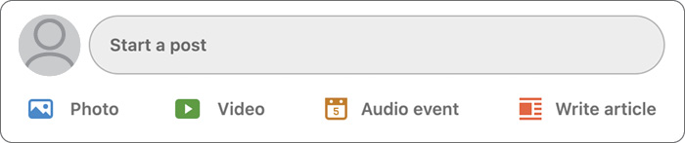
- Paste in the text for the post you would like to publish.
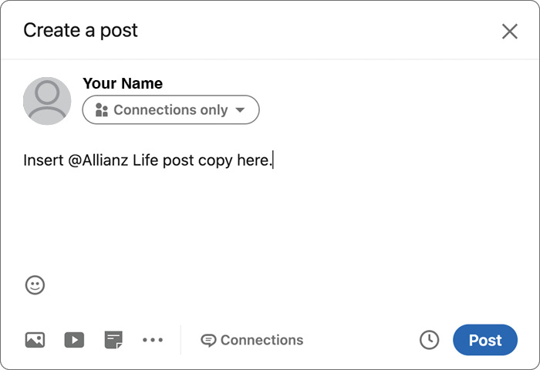

- Tag @AllianzLife by clicking next to our handle and selecting our account.
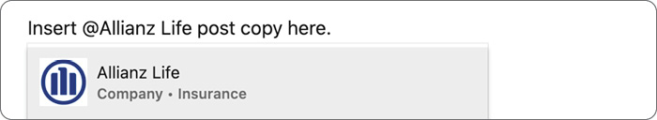
- Select the correct image for the corresponding text by clicking on the image icon and browsing on your computer to where you saved the image.
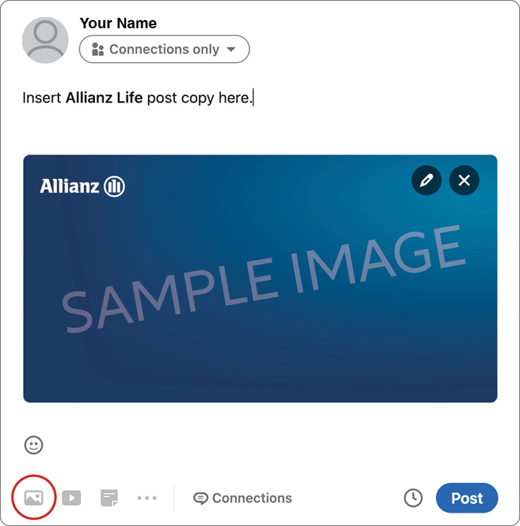
- Click “post” to publish to your feed.

